

**Artificial Intelligence Project Report**

**[ Face Mask Detector ]**

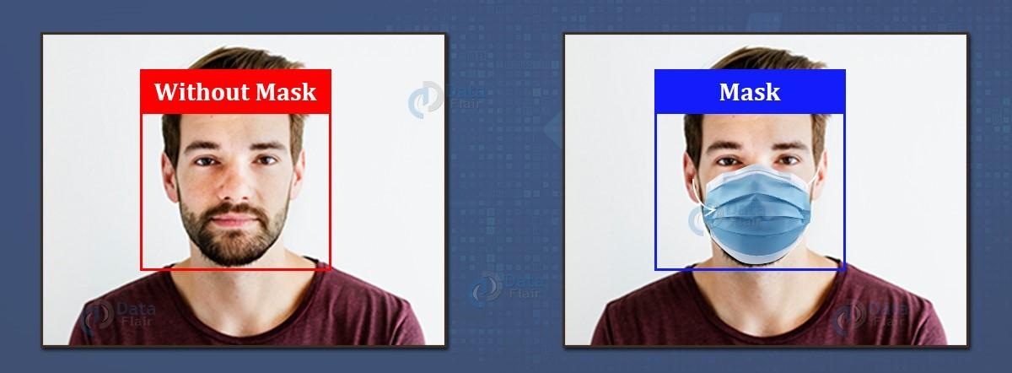

**Supervised**

Dr Fahad Sherwani

**Group Members**

Muhammad Naeem 18k-1140

Muhammad Faseeh 18k-1128

Arham Khalid 18k-0314

**Section** 6G

**Abstract:**

The year 2020 has shown mankind some mind-boggling series of events amongst which the COVID-19 pandemic is the most life-changing event which has startled the world since the year began. Affecting the health and lives of masses, COVID-19 has called for strict measures to be followed in order to prevent the spread of disease. From the very basic hygiene standards to the treatments in the hospitals, people are doing all they can for their own and the society’s safety; face masks are one of the personal protective equipment. People wear face masks once they step out of their homes and authorities strictly ensure that people are wearing face masks while they are in groups and public Places. To monitor that people are following this basic safety principle, a strategy should be developed. A face mask detector system can be implemented to check this. Face mask detection means to identify whether a person is wearing a mask or not. The ﬁrst step to recognize the presence of a mask on the face is to detect the face, which makes the strategy divided into two parts: to detect faces and to detect masks on those faces. Face detection is one of the applications of object detection and can be used in many areas like security, biometrics, law enforcement and more. There are many detector systems developed around the world and being implemented. However, all this science needs optimization; a better, more precise detector, because the world cannot afford any more increase in corona cases.

So Basically, in this project we are going to implement the mobile app, which can detect the mask on a human face by using the TFLite Model.

**Introduction:**

This idea behind this project is to implement a system which can detect the mask on human face, if someone interact with our system, without wearing a mask will be warned by our system, because this is basically implements to make sure that every person that interacts with our system is following a SOP’s, and that’s how we can reduce the ratio of covid positivity among the peoples.

**Background:**

The rapid outbreak of COVID-19 has caused serious harm and infected tens of millions of people worldwide. Since there is no specific treatment, wearing masks has become an effective method to prevent the transmission of COVID-19 and is required in most public areas, which has also led to a growing demand for automatic real-time mask detection services to replace manual reminding. In the present scenario due to Covid-19, there are no efficient face mask detection applications which are now in high demand for transportation means, densely populated areas, residential districts, large-scale manufacturers and other enterprises to ensure safety. Also, the absence of large datasets of ‘with_mask’ images has made this task more cumbersome and challenging.

**Methodology:**

The working of the Single Shot Detector algorithm relies on an input image with a speciﬁed bounding box against the objects. The methodology of predicting an object in an image depends upon a very renowned convolution fashion. For each pixel of a given image, a set of default bounding boxes (usually 4) with different sizes and aspect ratios are evaluated. Moreover, for all the pixels, a conﬁdence score for all possible objects are calculated with an additional label of ‘With Mask/Without Mask’. This calculation is repeated for many different feature maps, And it;s the same strategy that we’ve used in all of our three categories, either you’re detecting a mask from an image selected from the gallery, or captured by yourself, or real time detection

**Design (Architecture):**

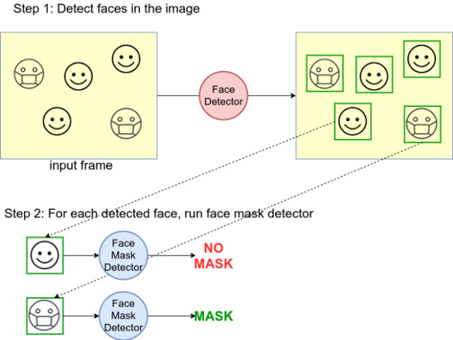

This system can be used in real-time applications which require face-mask detection for safety purposes due to the outbreak of Covid-19. This project can be integrated with embedded systems for application in airports, railway stations, offices, schools, and public places to ensure that public safety guidelines are followed.

**Dataset:**

The dataset which we have used consists of 4803 total images out of which 2855 are of masked faces and 1948 are of unmasked faces. All the images are actual images extracted from Google Search API, Kaggle datasets and RMFD dataset. From all the three sources, the proportion of the images is equal. The images cover diverse races i.e Asian, Caucasian etc. The proportion of masked to unmasked faces determine that the dataset is balanced.

We need to split our dataset into two parts: training dataset and test dataset dataset. The purpose of splitting data is to avoid overﬁtting which is paying attention, Data is split as per a split ratio which is highly dependent on the type of model we are building and the dataset itself. If our dataset and model are such that a lot of training is required, then we use a larger chunk of the data just for training which is our case. If the model has a lot of hyperparameters that can be tuned, then we need to take a higher amount of validation dataset. Models with a smaller number of hyperparameters are easy to tune and update, and so we can take a smaller validation dataset.

In our approach, we have dedicated 80% of the dataset as the training data and the remaining 20% as the testing data, which makes the split ratio as 0.8:0.2 of train to test set. Out of the training data, Overall, 80% of the dataset is used for training and 20% for testing.

**Result:**

**(Capture From Camera)**

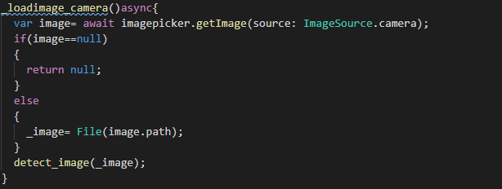**Output:**

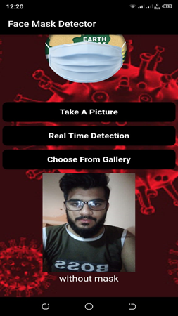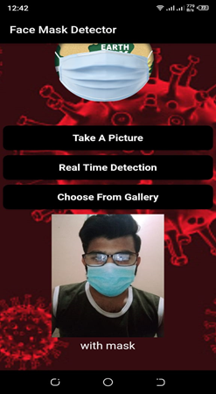

**(Real Time Detection)**

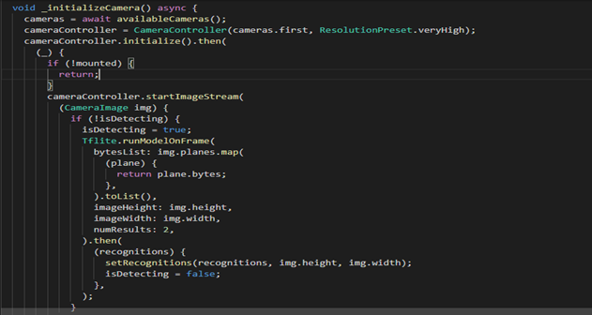

**Output:**

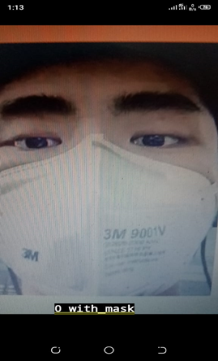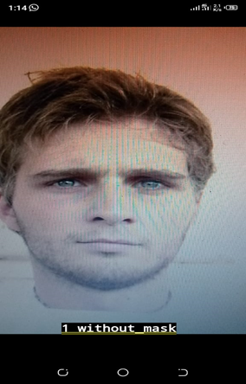

**(Take Picture From Gallery)**

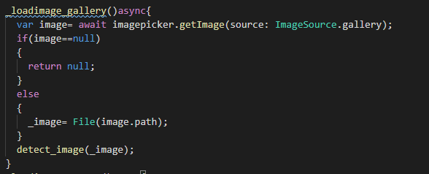

**Output:**

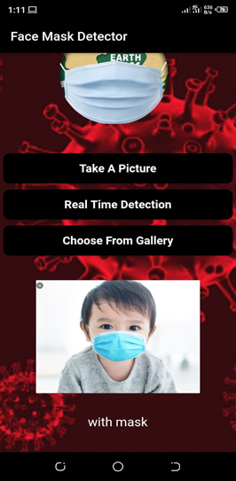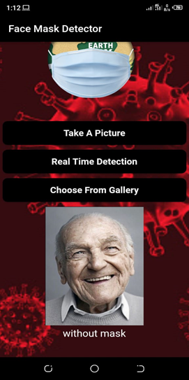

**Role Of Each Group Member:**

|  |  |
| --- | --- |
| Muhammad Naeem [18K-1140] | 35% |
| Muhammad Faseeh [18K-1128] | 35% |
| Arham Khalid [18K-0314] | 30% |

**Future Work:**

In our future work, we will collect more data and make a balance between different categories of the data to improve the model.We may also investigate the development of highly robust detectors by training a deep learning model with respect to specified face-feature categories or to correctly and incorrectly worn mask categories.

**Conclusion:**

To mitigate the spread of COVID-19 pandemic, measures must be taken. We have modeled a face mask detector using Tflite model architecture. To train, validate and test the model, we used the dataset that consisted of 2855 masked faces images and 1948 unmasked faces images. These images were taken from various resources like Kaggle and RMFD datasets. The model was inferred on images and live video streams. This face mask detector can be deployed in many areas like shopping malls, airports and other heavy trafﬁc places to monitor the public and to avoid the spread of the disease by checking who is following basic rule

**References:**

* [**https://www.youtube.com/watch?v=Ax6P93r32KU**](https://www.youtube.com/watch?v=Ax6P93r32KU)
* [**https://www.youtube.com/watch?v=T9KfYaS9hwQ**](https://www.youtube.com/watch?v=T9KfYaS9hwQ)
* [**https://www.youtube.com/watch?v=d3DJqucOq4g**](https://www.youtube.com/watch?v=d3DJqucOq4g)